ERS DAY 5
- create a struct order contains struct customer,struct item,.implement function to print complete orderdetails

#include <stdio.h>

struct Customer {
int id;
char name[20];
};

struct Item {
char itemName[20];
int qty;
};

struct Order {
struct Customer c;
struct Item i;
};

void printOrder(struct Order o) {
printf("Customer ID : %d\n", o.c.id);
printf("Customer Name : %s\n", o.c.name);
printf("Item Name : %s\n", o.i.itemName);
printf("Quantity : %d\n", o.i.qty);
}

int main() {
struct Order o = {
{1, "bob"},
{"Pen", 5}
};

printOrder(o);
return 0;
}
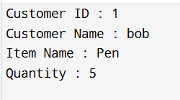

2. define enum statused with values pending shippeed deliver.write a program to update and display order status using the enum
#include <stdio.h>

enum status {
PENDING,
SHIPPED,
DELIVERED
};

void displayStatus(enum status s) {
if (s == PENDING)
printf("Order Status : Pending\n");
else if (s == SHIPPED)
printf("Order Status : Shipped\n");
else if (s == DELIVERED)
printf("Order Status : Delivered\n");
}

int main() {
enum status s;

s= PENDING;
displayStatus(s);

s = SHIPPED;
displayStatus(s);

s = DELIVERED;
displayStatus(s);

return 0;
}
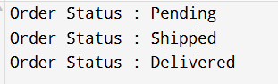

3.create a union data that can store either int float or string .demonstrate how memory usage refers from a structure
#include <stdio.h>
#include <string.h>

union Data {
int i;
float f;
char str[20];
};

struct DataStruct {
int i;
float f;*
char str[20];
};

int main() {
union Data u;
struct DataStruct s;

u.i = 10;
printf("Union int : %d\n", u.i);

u.f = 5.5;
printf("Union float : %.1f\n", u.f);

strcpy(u.str, "Hello");
printf("Union string : %s\n", u.str);

printf("\nSize of union : %lu bytes\n", sizeof(u));
printf("Size of struct : %lu bytes\n", sizeof(s));

return 0;
}
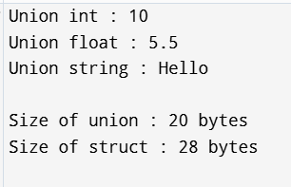
4.calculator
#include <stdio.h>

int add(int a, int b) { return a + b; }
int subtract(int a, int b) { return a - b; }
int multiply(int a, int b) { return a * b; }
int divide(int a, int b) {
if (b != 0) return a / b;
else {
printf("Error\n");
return 0;
}
}

int main() {
int x, y, choice, result;

int (*calc[])(int, int) = {add, subtract, multiply, divide};

printf("Enter ");
scanf("%d %d", &x, &y);

printf("Select :\n");
printf("1. Add\n2. Subtract\n3. Multiply\n4. Divide\n");
scanf("%d", &choice);

if(choice < 1 || choice > 4) {
printf("Invalid\n");
return 0;
}

result = calc[choice - 1](x, y);
printf("Result = %d\n", result);

return 0;
}

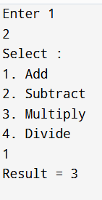
5. read int from a file and write sorted result to another file (text mode)
#include <stdio.h>

int main() {
FILE *fp1, *fp2;
int a[100], n = 0, i, j, temp;

fp1 = fopen("input.txt", "r");
fp2 = fopen("output.txt", "w");

if (fp1 == NULL || fp2 == NULL) {
printf("File error\n");
return 1;
}

while (fscanf(fp1, "%d", &a[n]) != EOF) {
n++;
}

for (i = 0; i < n - 1; i++) {
for (j = i + 1; j < n; j++) {
if (a[i] > a[j]) {
temp = a[i];
a[i] = a[j];
a[j] = temp;
}
}
}
for (i = 0; i < n; i++) {
fprintf(fp2, "%d ", a[i]);
}

fclose(fp1);
fclose(fp2);
}
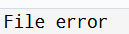
6.linear search
#include <stdio.h>

int main() {

int arr[]={5,4,3,2};
int n=4;
int key=4;
int index = -1;
for(int i=0;i<n;i++){
if(arr[i] == key){
index = i+1;
printf("Found at %d",index);
break;
}
}
if(index == -1){
printf("Not found");
}
}
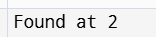
7.Quick sort
#include <stdio.h>

void swap(int *a, int *b) {
int temp = *a;
*a = *b;
*b = temp;
}

int partition(int a[], int low, int high) {
int pivot = a[high];
int i = low - 1;

for (int j = low; j < high; j++) {
if (a[j] < pivot) {
i++;
swap(&a[i], &a[j]);
}
}
swap(&a[i + 1], &a[high]);
return i + 1;
}

void quickSort(int a[], int low, int high) {
if (low < high) {
int pi = partition(a, low, high);
quickSort(a, low, pi - 1);
quickSort(a, pi + 1, high);
}
}

int main() {
int a[] = {9, 3, 7, 1, 5};
int n = 5;

quickSort(a, 0, n - 1);

printf("Sorted array: ");
for (int i = 0; i < n; i++)
printf("%d ", a[i]);

return 0;
}
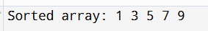
8.Balanced
#include <stdio.h>

int main() {
char exp[100], stack[100];
int top = -1;

printf("Enter expression: ");
scanf("%s", exp);

for (int i = 0; exp[i] != '\0'; i++) {

if (exp[i] == '(' || exp[i] == '{' || exp[i] == '[')
stack[++top] = exp[i];

else if (exp[i] == ')' || exp[i] == '}' || exp[i] == ']') {

if (top == -1) {
printf("Not Balanced\n");
return 0;
}

char open = stack[top--];

if ((open == '(' && exp[i] != ')') ||
(open == '{' && exp[i] != '}') ||
(open == '[' && exp[i] != ']')) {
printf("Not Balanced\n");
return 0;
}
}
}

if (top == -1)
printf("Balanced\n");
else
printf("Not Balanced\n");

return 0;
}
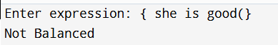
9.circular array
#include <stdio.h>
#define N 5

int q[N], front = -1, rear = -1;

void enqueue(int x) {
if ((rear + 1) % N == front) {
printf("Full\n");
return;
}
if (front == -1) front = 0;
rear = (rear + 1) % N;
q[rear] = x;
}

void dequeue() {
if (front == -1) {
printf("Empty\n");
return;
}
if (front == rear)
front = rear = -1;
else
front = (front + 1) % N;
}

void display() {
if (front == -1) return;
int i = front;
while (1) {
printf("%d ", q[i]);
if (i == rear) break;
i = (i + 1) % N;
}
printf("\n");
}

int main() {
enqueue(1);
enqueue(2);
enqueue(3);
enqueue(4);
display();

dequeue();
enqueue(5);
enqueue(6);
display();

return 0;
}
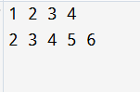
10.queue using 2 stacks
#include <stdio.h>
#define N 100

int s1[N], s2[N];
int top1 = -1, top2 = -1;

void push(int stack[], int *top, int x) {
stack[++(*top)] = x;
}

int pop(int stack[], int *top) {
return stack[(*top)--];
}

void enqueue(int x) {
push(s1, &top1, x);
printf("Enqueued: %d\n", x);
}

void dequeue() {
if (top1 == -1 && top2 == -1) {
printf("Queue is empty\n");
return;
}

if (top2 == -1) {
while (top1 != -1) {
push(s2, &top2, pop(s1, &top1));
}
}

printf("Dequeued: %d\n", pop(s2, &top2));
}

int main() {
enqueue(10);
enqueue(20);
enqueue(30);

dequeue();
dequeue();

enqueue(40);
dequeue();

return 0;
}
